What is Node Cover?

In the graph theory, a node (vertex) cover of a graph is a set of vertices that includes at least one endpoint of every edge of the graph. The problem of finding a minimum vertex cover is a classical optimization problem in computer science and is a typical example of an NP-hard optimization problem that has an approximation algorithm.
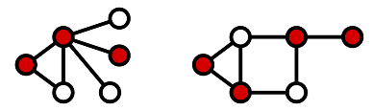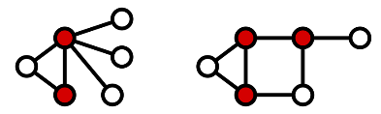
(this figure shows that the minimum vertex cover of this graph)

Applications in Real-World
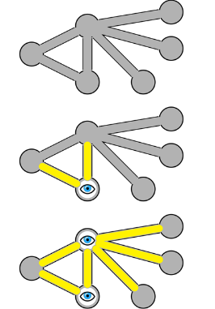
Vertex cover optimization serves as a model for many real-world and theoretical problems. For example, a commercial establishment interested in installing the fewest possible closed circuit cameras covering all hallways (edges) connecting all rooms (nodes) on a floor might model the objective as a vertex cover minimization problem.
Approximate Algorithm for Vertex Cover
1) Initialize the result as {}
2) Consider a set of all edges in given graph. Let the set be E.
3) Do following while E is not empty
...a) Pick an arbitrary edge (u, v) from set E and add 'u' and 'v' to result
...b) Remove all edges from E which are either incident on u or v.
4) Return result

